Commercial Worker’s Compensation is heavily regulated by the states. However, there are some things that are consistent across the states. For example, the format used on the Dec pages, is used consistently for all states that we currently write. The format was copied from what NCCI (a standardized forms company) suggests for dec pages. Most of the forms used by Worker’s Comp (WCP) also come from NCCI.
In many ways, Worker's Comp is unlike any other product, but there are some things that will look familiar – just presented in a different order or a slightly different way.
For example, the Named Insureds, Schedule of Locations, and Forms Listings are all included on the dec and quote for WCP, but they are in a different order than the other products. They also have item numbers for each section (similar to CL Auto) but EVERY section has a number instead of just the coverages. The Premium Summary section is on the second page instead of the first page.
Coverages are generally shown with their class codes (similar to GL), however they do not have a rating basis or exposure amount. WCP coverages are based on “remuneration” which is the total compensation received by an employee. So this is not just their salary, but would include any benefits, commissions, or other bonuses the employee might earn. (Yes I looked this up!)
As we look at the class code table, we see the “estimated total annual remuneration” column as well as a rate and an “estimated premium”. And you have probably guessed by now that since there is estimation involved, that also means a Premium Audit would be done – and you would be right!
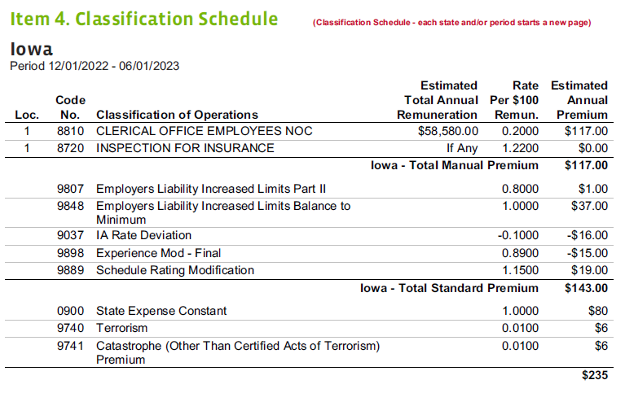
The coverages are grouped by “Manual Premium” and “Standard Premium” and then there is a final section for other coverages that do not fit in the other 2 categories. Note that all coverages and premiums are shown per state and each state starts a new page. This in turn means that the data is stored per state as well, which corresponds to the “Jurisdiction” node in the PC payload:
/PrintDTO_GRG/PrintPayload/PolicyPeriod/WCMLine/WCMJurisdictions/Entry/Coverages/Entry
We are now adding new functionality to accommodate a split premium period, which is triggered by the “Experience Mod” being added via amendment to the policy. If there is a split premium period, then each premium period for that state starts a new page. (There can be 2 or more premium periods on the policy.) I believe the splits correspond to the number of mid-term amendments on the policy. This also impacts the start/end dates of the periods. They do not have to be evenly spaced across the term of the policy.

